

Semester 2, Session 2025/2026
SCSE2243 APPLICATION DEVELOPMENT I
SECTION 01
PROJECT PROPOSAL

UTM BORROW

A Campus-Wide Circular Resource Sharing Platform
Prepared For | DR. MOHD YAZID BIN IDRIS
Submission Date | 21 - APRIL 2026
Group Name | Alpha

NAME | MATRIC NUMBER
MOHAMMED MOHSEN MOHAMMED ALSAKKAF | A23CS4026
MUAZ IBNE AHMED | A23CS4062
AHMAT MAHAMAT MOURDJI MOUSTAPHA | A24CS4053

Faculty of Computing, Universiti Teknologi Malaysia

Table of Content
1. EXECUTIVE SUMMARY 2
2. PROJECT DOMAIN AND COMMUNITY BACKGROUND 3
2.1. The Current Problem Space 3
2.2. Community and Stakeholder Context 3
3. PROBLEM ANALYSIS 4
3.1. QUESTIONNAIRES 4
3.1.1. Demographic information 4
3.1.2. Buying and selling behavior 6
3.1.3. COMMUNICATION AND PAYMENT PREFERENCES 7
3.1.4. CHALLENGES AND SAFETY CONCERNS 8
3.1.5. TRUST AND PLATFORM PERCEPTION 9
4. PROBLEM STATEMENT 11
4.1. Problem 1: Financial Drain from Single-Use Academic Purchases 11
4.2. Problem 2: Absence of Trust Infrastructure in Existing Sharing Channels 11
4.3. Problem 3: No Accountability Mechanism for Item Returns and Condition 11
4.4. Problem 4: Wasted Campus Resources and Environmental Impact 11
5. GOAL AND OBJECTIVE 12
5.1. Overarching Project Goal 12
5.2. Core Technical Objectives 12
6. PROPOSED APPLICATION 13
6.1. Identity & User Management Subsystem(Ahmat) 14
6.1.1. Authentication Module 14
6.1.2. Profile & Trust Score 14
6.1.3. User Activity Dashboard 14
6.2. Resource Catalog & Discovery Subsystem(Muaz) 15
6.2.1. Item Listing & Management 15
6.2.2. Category & Condition Metadata 15
6.2.3. Location-Based Filter 15
6.3. Transaction & Handover Subsystem(Alsakkaf) 16
6.3.1. Request & Approval Workflow 16
6.3.2. QR Verification Module 16
6.3.3. Community Moderation & Reporting 16
7. PROPOSED TECHNOLOGY AND TOOLS USED 17
7.1. Modeling & Project Management Tools 17
7.2. Project Management and Collaboration (Jira, GitHub, Visual Paradigm) 17
8. PROJECT BENEFITS 18
8.1. Benefits for UTM Students (Financial & Space) 18
8.2. Benefits for UTM Administration and UTMCS 18
8.3. Environmental Impact for the University 18
8.4. Future Entrepreneurial and Scaling Potential 18
9. PROJECT SCHEDULE 19
10. TEAM MEMBERS AND ROLES 20
10.1. Subsystems and Responsible Team Members 20
10.2. Waterfall Phase Responsibilities 20
11. INDIVIDUAL SCHEDULE 21
11.1. AHMAT MAHAMAT MOURDJI MOUSTAPHA — :Identity & User Management 21
11.2. MUAZ IBNE AHMED — : Resource Catalog & Discovery 21
11.3. MOHAMMED MOHSEN MOHAMMED ALSAKKAF — :Transaction & Handover 21

EXECUTIVE SUMMARY
This project proposes a new mobile application called UTM Borrow, designed specifically as a circular resource-sharing platform for the Universiti Teknologi Malaysia (UTM) community. The main goal is to facilitate a secure, centralized environment where students and staff can lend and borrow academic resources such as laboratory tools, engineering equipment, textbooks, and event clothing. Currently, students face severe financial constraints purchasing single-use expensive tools, while campus sustainability suffers from post-semester disposal waste.
Unlike unverified WhatsApp or Telegram groups, UTM Borrow introduces strict trust mechanics. The system authenticates users via verified UTM student credentials and manages item handovers utilizing cryptographic QR code scanning to guarantee accountability and ensure items are safely returned..
In alignment with the course syllabus, this project will follow a sequential Software Development Life Cycle (SDLC) process, culminating in a fully interactive, High-Fidelity Prototype. The development methodology incorporates Generative AI for modern requirement engineering, Visual Paradigm for rigorous UML system modeling, and Figma for collaborative UI/UX frontend prototyping. To distribute the workload evenly, the application architecture is divided into three distinct subsystems:
Identity & User Management,
Resource Catalog & Discovery,
and Transaction & Handover.
This streamlined structure allows each team member to focus on a core functional domain while ensuring the system remains lightweight and efficient for the campus environment.

PROJECT DOMAIN AND COMMUNITY BACKGROUND

The Current Problem Space
The student community at Universiti Teknologi Malaysia (UTM) frequently encounters financial barriers due to short-term academic requirements. Many courses and extracurricular activities require students to acquire specific, high-cost items—such as scientific laboratory equipment, engineering drawing tools, formal presentation attire, or specialized electronics—that are often only utilized for a single semester or project.
Currently, the primary ecosystem for acquiring these temporary items relies on new purchases or unstructured peer-to-peer sharing via informal channels like Telegram or WhatsApp. These channels are heavily fragmented, unmoderated, and lack basic trust mechanisms, resulting in buried requests, potential scams, and high anxiety for lenders. Consequently, the absence of a centralized borrowing platform leads to redundant purchases, financial strain on lower-income students, and the accumulation of post-semester waste across residential colleges

Community and Stakeholder Context
UTM Borrow establishes a localized circular economy that actively benefits three main stakeholders within the campus ecosystem:
- Student Borrowers: Students seeking cost-effective, temporary access to academic and lifestyle resources. They require a centralized, easily searchable directory filtered by their residential colleges or faculties to locate available items quickly without financial strain.
- Student Lenders: Students who possess underutilized resources. To confidently lend their assets, they require a secure, verified environment with identity tracking, QR handover protocols, and rating systems to ensure their items are treated with respect and returned promptly.
- UTM Administration/Moderators: University representatives tasked with overseeing student welfare and preventing scams. They require a simplified moderation interface to review reported items and manage user access, ensuring the community remains safe and aligned with UTM’s 'Smart and Green Campus' objectives.

PROBLEM ANALYSIS

To gather information about the problems faced by the community regarding campus resource sharing, our team conducted a distributed questionnaire.

QUESTIONNAIRES
We distributed our questionnaire to reach UTM students across different levels and faculties. Eventually, we managed to gather 29 responses.

Demographic information

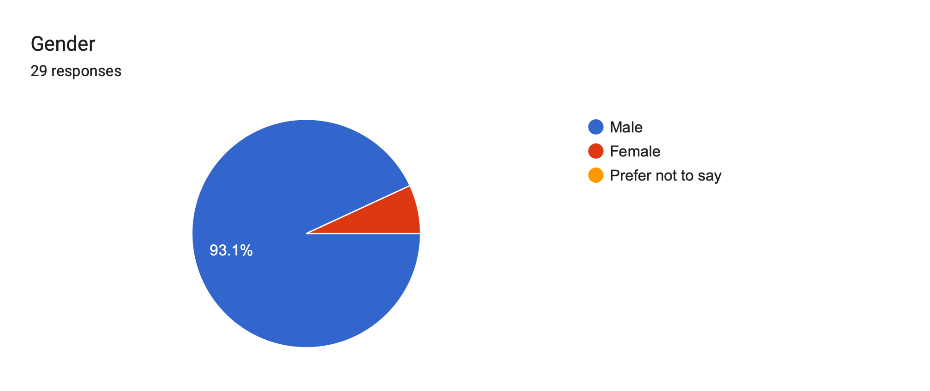
Figure 3.1: Gender distribution of respondents
Based on Figure 3.1, a total of 29 respondents participated in the survey. Among them, 93.1% were male. This indicates that the vast majority of participants were male students, providing a specific baseline for our initial target audience analysis.
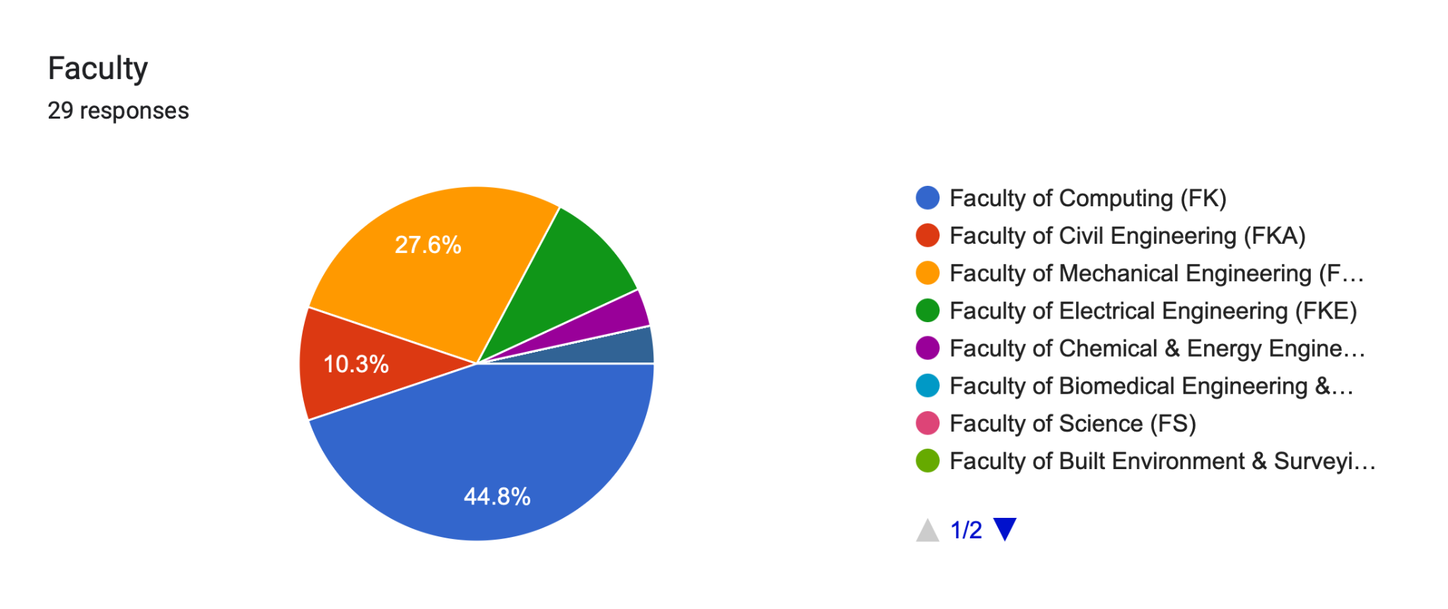 Figure 3.2: Faculty distribution of respondents

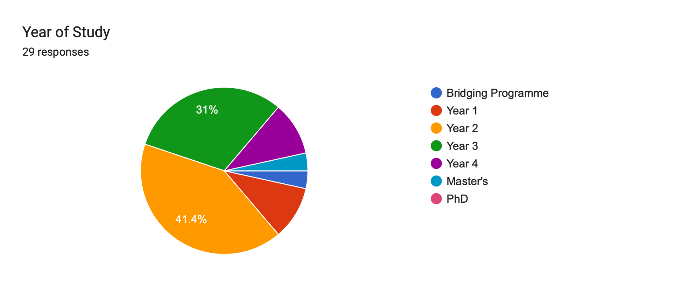Figure 3.3: Year of study distribution

The survey results show that a significant portion of respondents are from the Faculty of Computing (44.8%), followed by the Faculty of Civil Engineering (27.6%). Regarding their academic progress, 41.4% are Year 3 students, and 31% are Year 4 students. This indicates that upper-year engineering and computing students form the bulk of our respondents, likely due to their frequent need for specialized project materials and laboratory equipment.

Buying and selling behavior
Frequency of purchasing single-use academic items
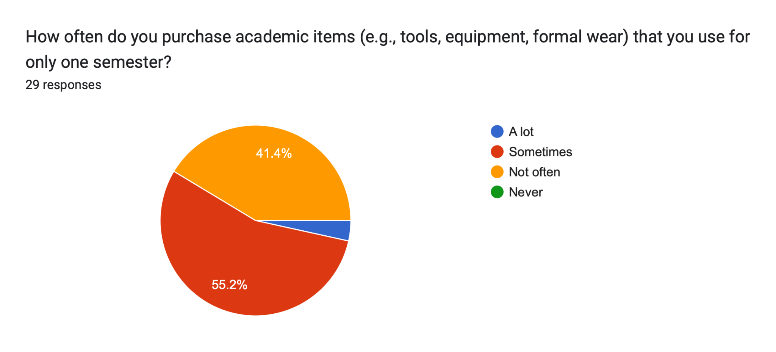
Figure 3.4: Frequency of purchasing items used for only one semester
Figure 3.4 illustrates how often students purchase academic items (like tools, equipment, or formal wear) that are utilized for only a single semester. The majority (55.2%) do this "Sometimes," while a large segment (41.4%) do it "A lot". This highlights a pervasive "buy-and-discard" culture on campus, confirming the strong need for a circular borrowing platform.
Money spent on one-time items
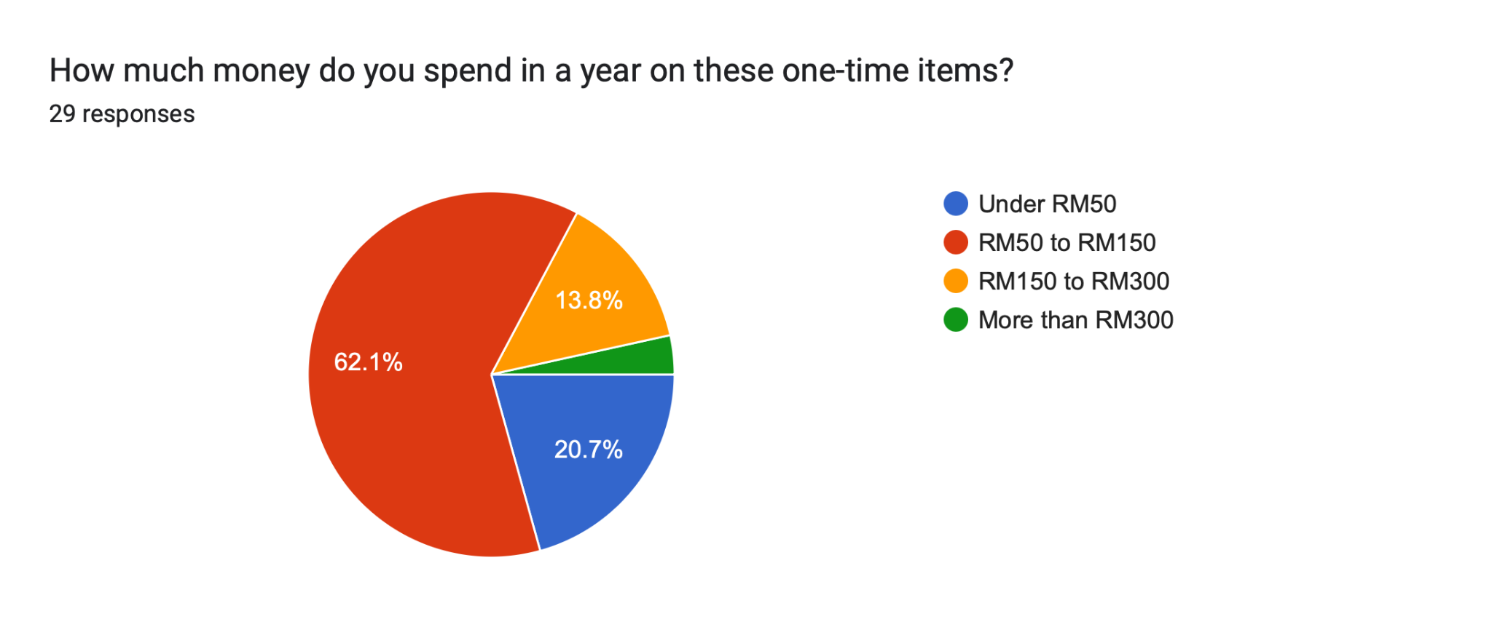
Figure 3.5: Annual expenditure on single-use items
According to Figure 3.5, 62.1% of students spend between RM50 to RM150 annually on these short-term items, and 20.7% spend between RM150 to RM300. This demonstrates the financial drain single-use purchases cause, underscoring the potential cost savings UTM Borrow can provide to the student body.
Reasons for keeping old items
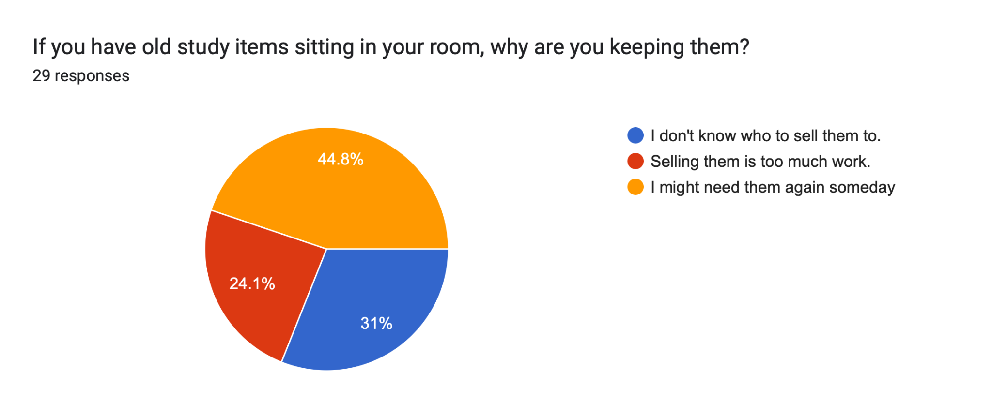
Figure 3.6: Reasons for holding onto old study items
When asked why they keep old study items in their rooms, 44.8% stated they "might need them again someday," 31% "don't know who to sell them to," and 24.1% feel "selling them is too much work". This indicates that a massive latent supply of shareable resources currently exists in dormitories, hindered only by the friction of finding borrowers.

COMMUNICATION AND PAYMENT PREFERENCES
Preferred Digital Payment Method
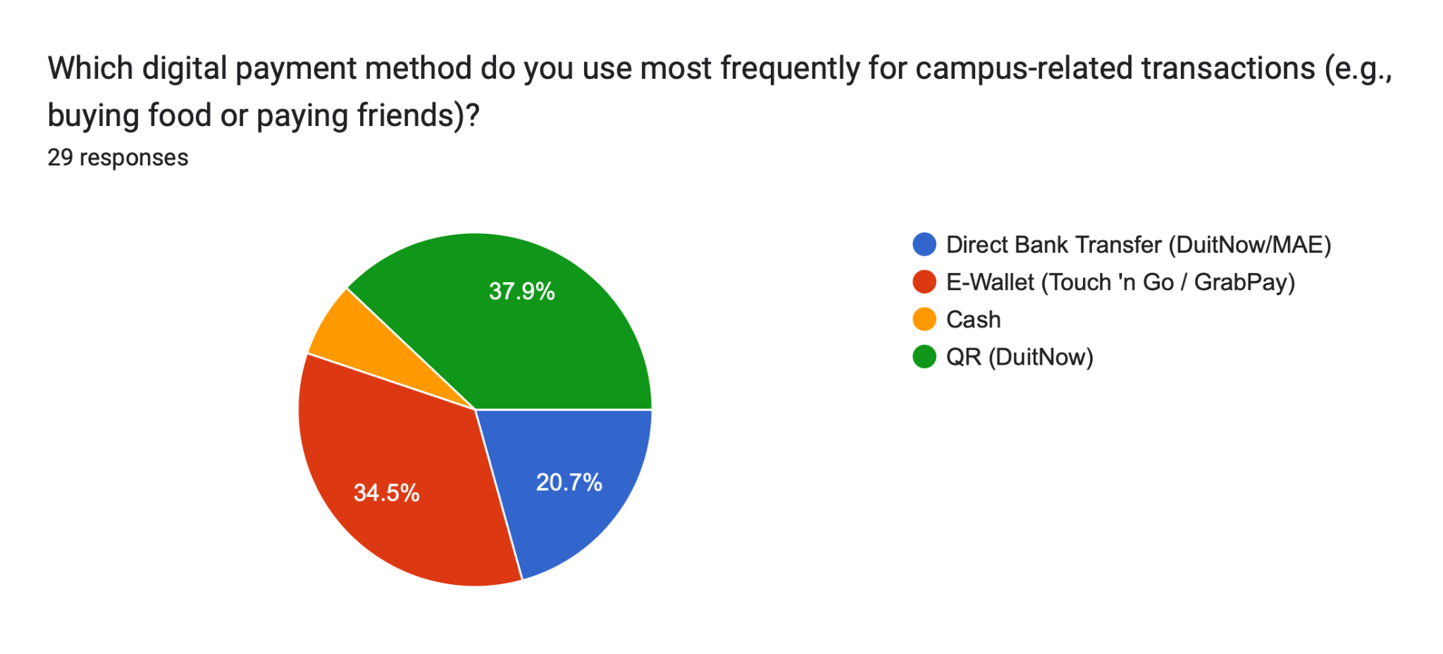
Figure 3.7: Preferred payment methods for campus transactions
Figure 3.7 reveals that E-Wallets (Touch 'n Go / GrabPay) are the most preferred payment method at 37.9%, closely followed by QR (DuitNow) at 34.5% and Direct Bank Transfer at 20.7%. These findings strongly support the integration of verified identity and trust-based accountability measures within the UTM Borrow app.

CHALLENGES AND SAFETY CONCERNS
Efficiency of finding items
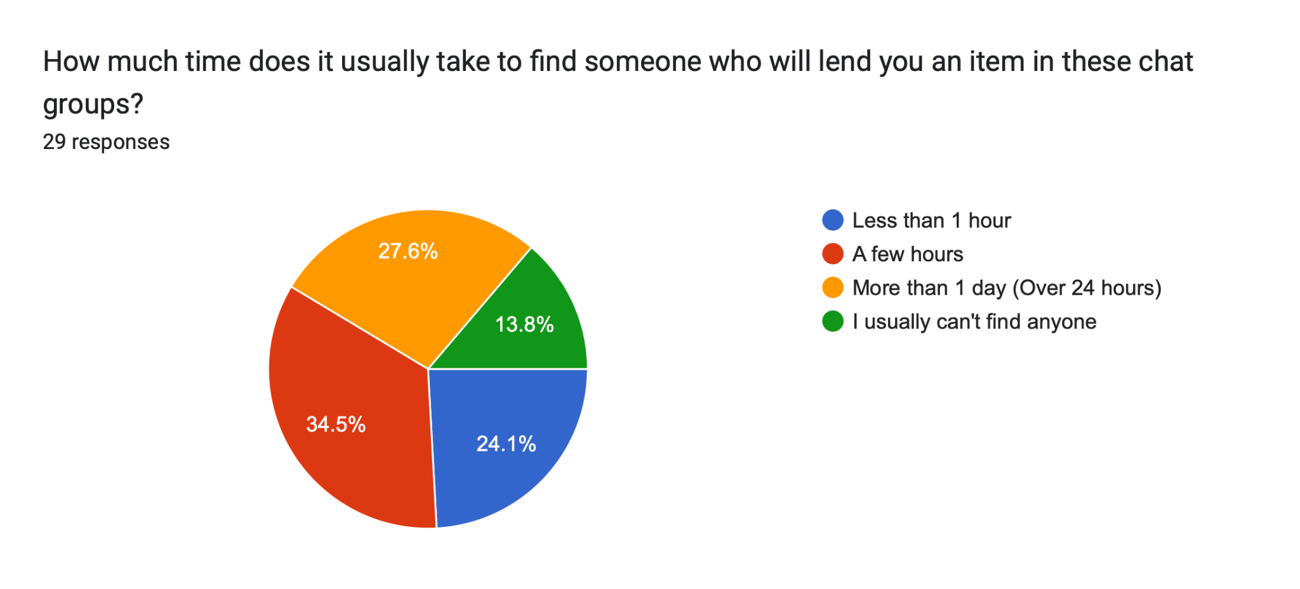
Figure 3.8: Time required to find lenders in existing chat groups
Figure 3.8 highlights the inefficiency of current sharing methods. 34.5% of students take more than 1 day to find an item, and 24.1% usually cannot find anyone at all. This validates the critical need for our localized Location-Based Filter Module and Category Metadata Module.
Biggest fear when lending
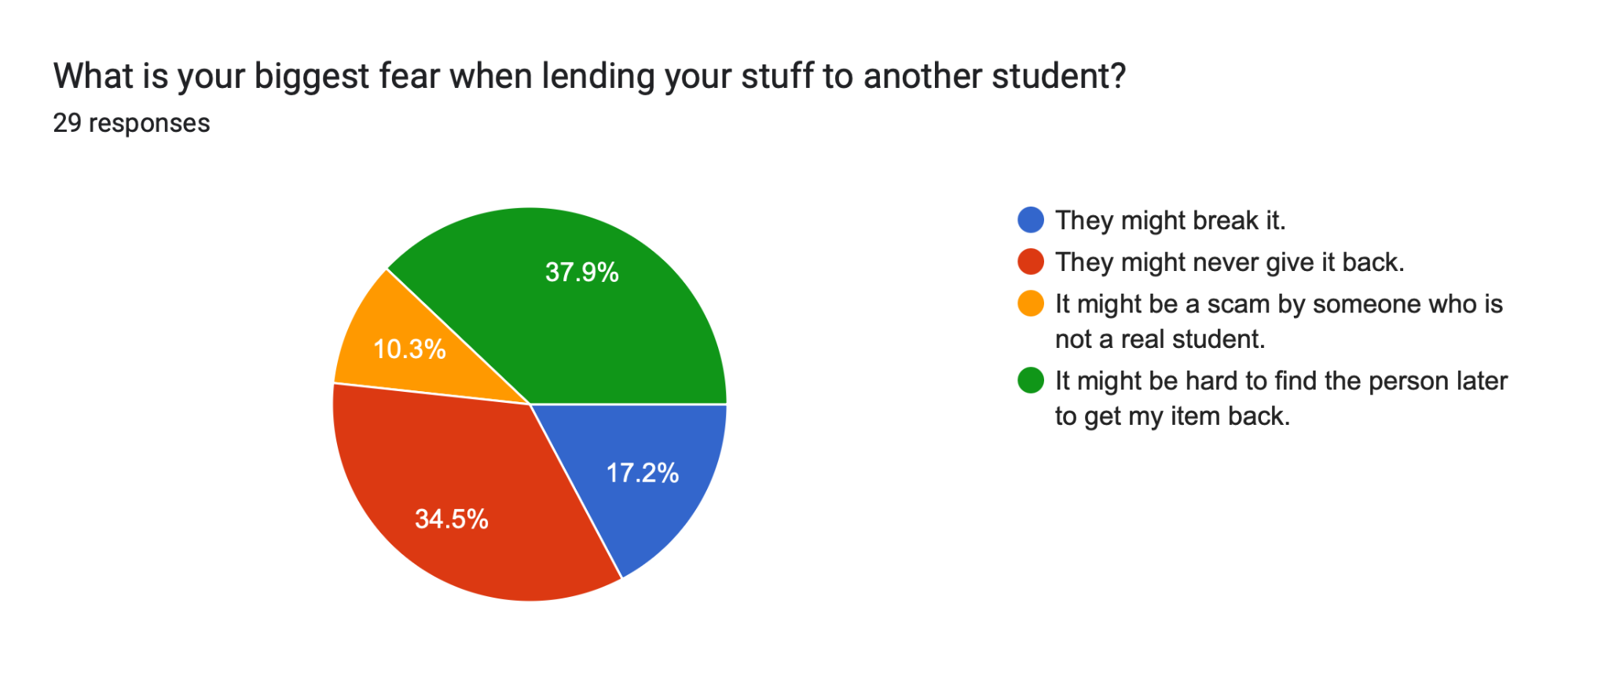
Figure 3.9: Primary concerns when lending items to other students
When lending items, the biggest fear is that the borrower "might never give it back" (37.9%), followed by the concern that "it might be hard to find the person later" (34.5%). Additionally, 55.2% of users currently only rely on "screenshots of our chat" as proof if an item breaks, and 31% have "no real proof at all". This massive lack of accountability justifies the need for UTM Borrow's digital condition logs and formal handover protocols.

TRUST AND PLATFORM PERCEPTION
Handling valuable items and deposits
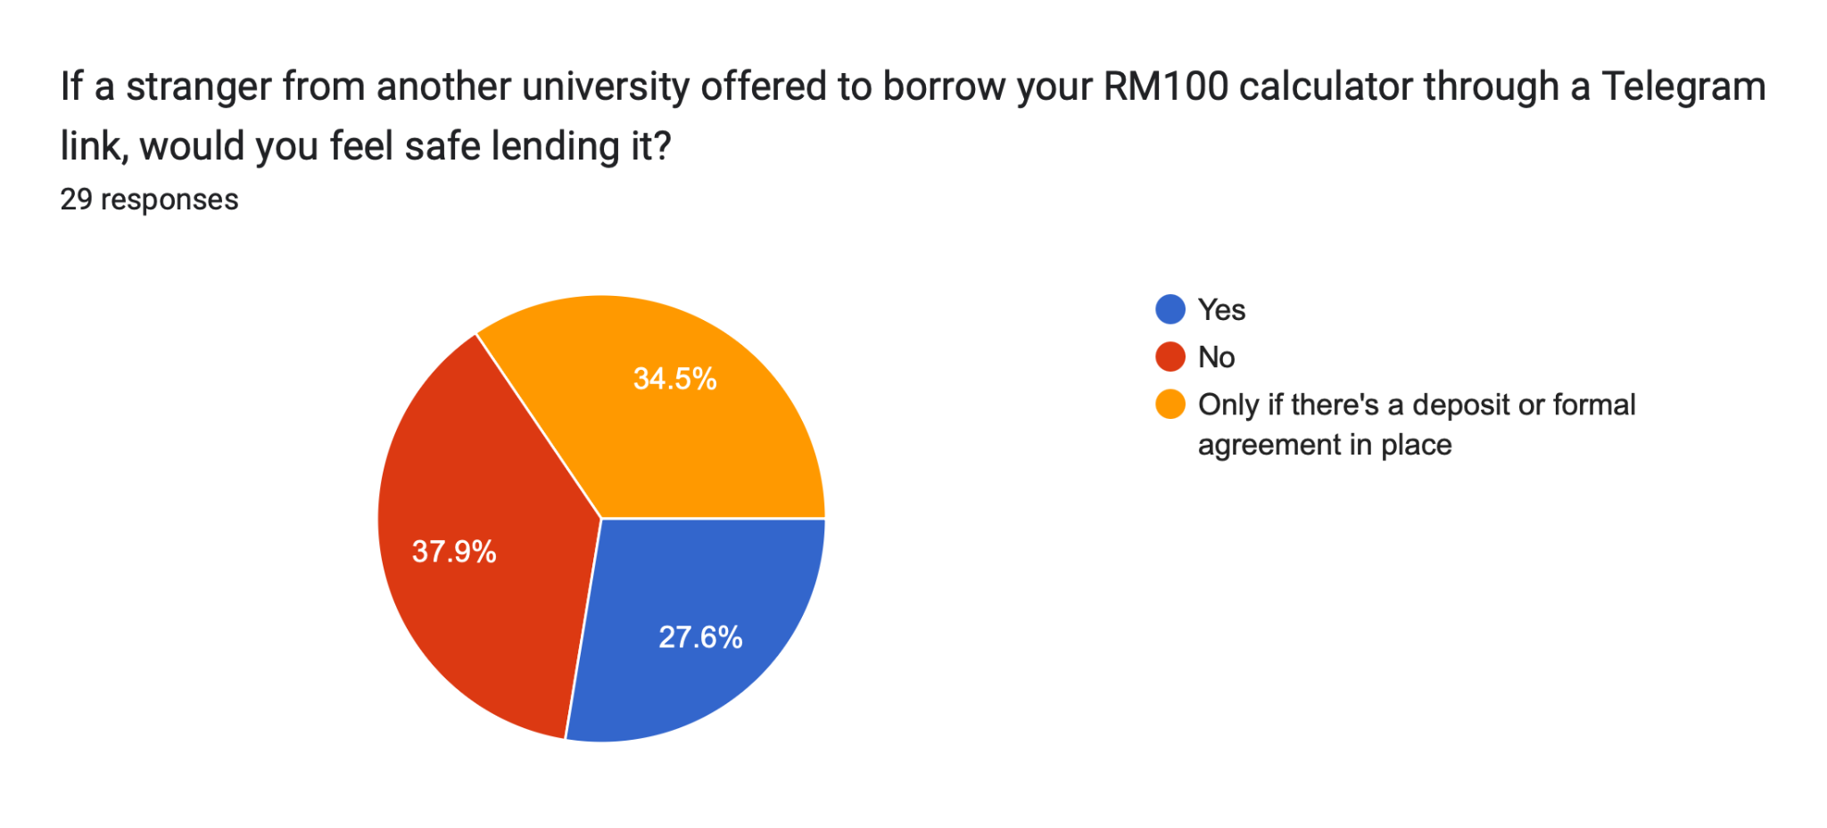
Figure 3.10: Preferences for ensuring the safe return of expensive items
According to Figure 3.10, while a segment of students expressed a preference for cash deposits, the data highlights a broader underlying need for guaranteed accountability. To address this without the complexity of financial transactions, UTM Borrow focuses on Official UTM Student Email Verification and a systematized Trust Score, which provides the safety students require while keeping the platform lightweight and easy to use.
Desired Application Features
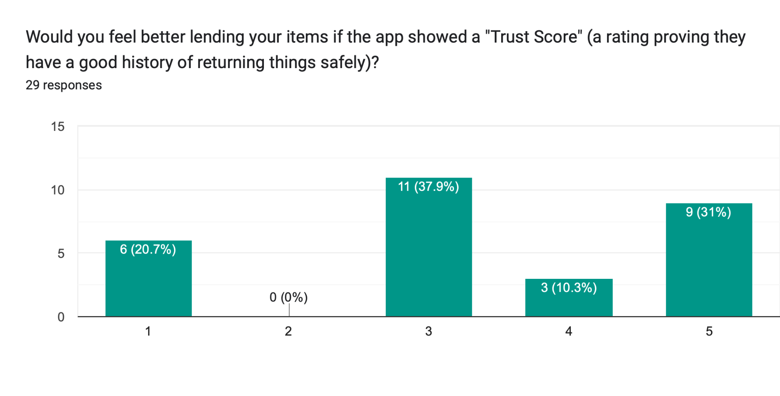
Figure 3.11: Receptiveness to Trust Scores
Respondents showed strong support for systemized safety features. A clear majority rated the implementation of a user "Trust Score" highly (Scores 3 to 5).
Sustainability and Identity Policies
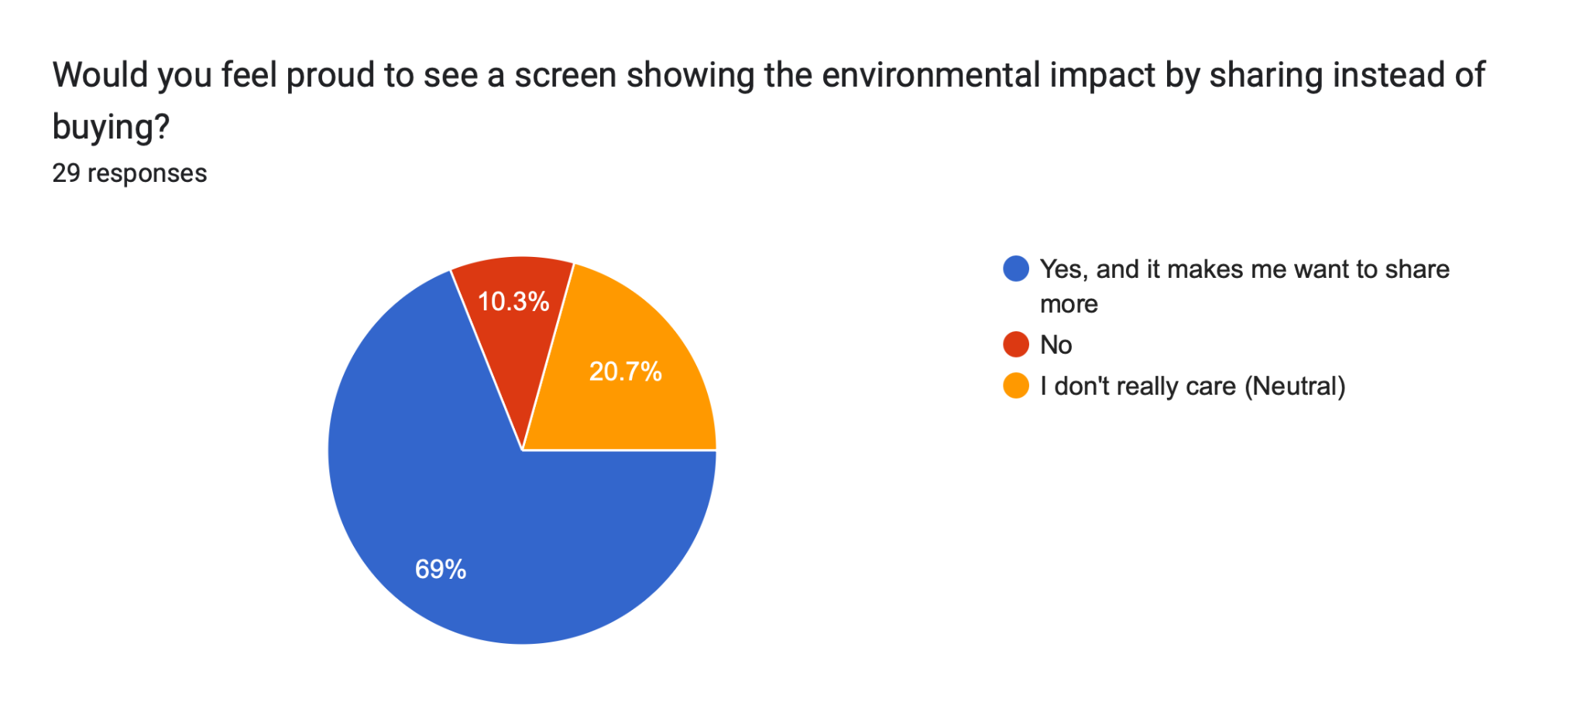

Figure 3.12: Perception of Dashboards and Authentication Policies

A significant 69% of students would feel proud to view an environmental impact dashboard

PROBLEM STATEMENT

Problem 1: Financial Drain from Single-Use Academic Purchases
UTM students face significant financial burdens purchasing specialized academic tools (e.g., lab coats, scientific calculators, presentation attire) for short-term use. The lack of a centralized campus sharing platform forces students to buy these items brand-new, disproportionately affecting those from lower-income backgrounds and exhausting their budgets on items that will lay dormant after one semester.

Problem 2: Absence of Trust Infrastructure in Existing Sharing Channels
Existing methods for peer-to-peer borrowing rely heavily on informal, unverified chat groups such as WhatsApp or Telegram. Because these platforms lack an official identity verification system linked to UTM credentials, students are highly vulnerable to scams and theft by non-affiliates. This profound lack of a trust profile and reputation system actively discourages owners from lending their valuable items.

Problem 3: No Accountability Mechanism for Item Returns and Condition
Campus resource sharing currently operates without formal handover protocols, condition tracking, or strict return deadlines. Lenders frequently face disputes over damaged items because there is no digital baseline or pre-handover photo log. Additionally, without an automated tracking and notification system, items are frequently returned late or completely forgotten, making the sharing process inherently risky for lenders.

Problem 4: Wasted Campus Resources and Environmental Impact
The persistent 'buy-and-discard' culture on campus results in immense redundancy, with identical tools repeatedly purchased every semester. Without a localized platform to connect lenders and borrowers, the university generates unnecessary academic waste and lacks a simple way for students to engage in a circular economy.

GOAL AND OBJECTIVE

Overarching Project Goal
The goal of this project is to develop UTM Borrow, a secure mobile platform that facilitates a circular economy within the Universiti Teknologi Malaysia community. By transitioning from a "buy-and-discard" habit to a managed borrowing ecosystem, the platform aims to reduce financial barriers for students while promoting university sustainability goals through high-fidelity design and rigorous sequential development.

Core Technical Objectives
- Identity Verification Engine: To implement a secure UTM Student Email Verification gateway that ensures all lenders and borrowers are verified university affiliates, preventing non-member access.
- Resource Discovery and College-Based Filtering: Allowing students to efficiently locate nearby items by filtering results based on specific residential college zones and faculty locations.
- Accountability and Tokenized Handover: To design a state-machine logic for item tracking, using QR-code verification to prove physical handover and safe return.
- Community Moderation & Reporting: To establish a basic management interface that allows staff to handle reported items and view simple community-wide impact reports.

PROPOSED APPLICATION
The UTM Borrow System follows a 3-tier modular architecture. This streamlined approach allows each of the three team members to lead a specific core domain, ensuring high-quality design and focused requirements analysis. The three subsystems are integrated to provide a seamless user journey from identity verification to item handover.
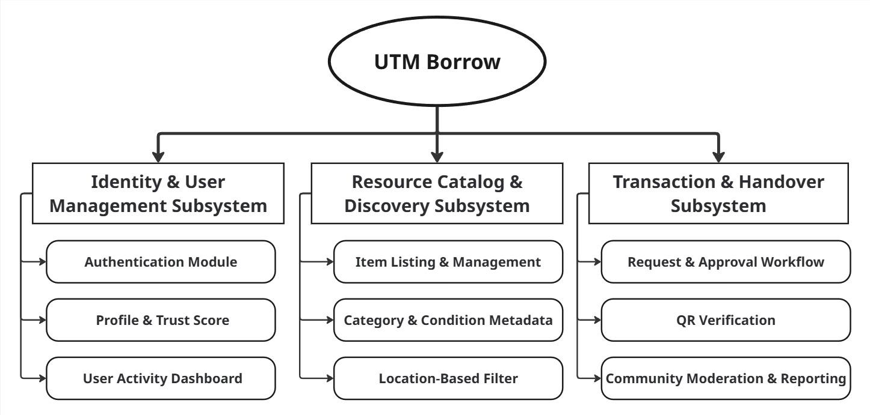
Figure 6.1.0.1:: Overview of UTM Borrow Subsystems and Modules

Subsystem | Use Cases | Derived From
Identity & User Management | Register, Login, View/Rate Profile, View Activity Dashboard | Authentication, Profile Trust, and Dashboard modules
Resource Catalog & Discovery | List Item, Search/Browse, Filter by College/Category | Item Listing, Metadata, and Location Filter modules
Transaction & Handover | Submit Request, Approve/Reject, QR Scan Handover, Report Item | Request Workflow, QR Verification, and Moderation modules
Figure 6.1.0.3:Subsystems & Use Cases Table

Identity & User Management Subsystem
This subsystem is responsible for managing user accounts and verifying identities to ensure a secure environment. It focuses on simplicity and transparency to build community trust.
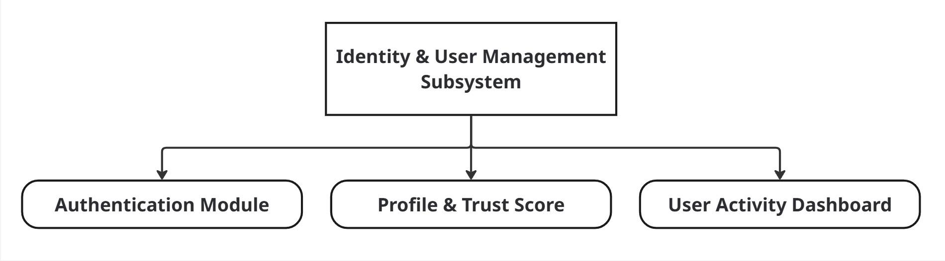
Figure 6.1 :

Authentication Module
Users register and log in using their official UTM student email. This ensures that only verified university members can access the platform, eliminating the risk of outside scammers.

Profile & Trust Score Module
Each user has a profile showing their sharing history. A simple 5-star rating system (Trust Score) allows borrowers and lenders to rate each other after a transaction, encouraging honest behavior. To guarantee accountability without financial complexity, the platform utilizes the official UTM Email identity. In cases of unreturned or severely damaged items, lenders can file an official non-compliance report through the app. Verified violations will be escalated directly to the UTM Administration for administrative disciplinary action, providing maximum security for student assets.

User Activity Dashboard Module
A central hub where users can view their active transactions. It provides a quick summary of "Items I am Lending" and "Items I am Borrowing" so users never lose track of their commitments.

Resource Catalog & Discovery Subsystem
This subsystem enables users to browse available resources and list their own items for sharing. It focuses on making items easy to find without complex GPS mapping.
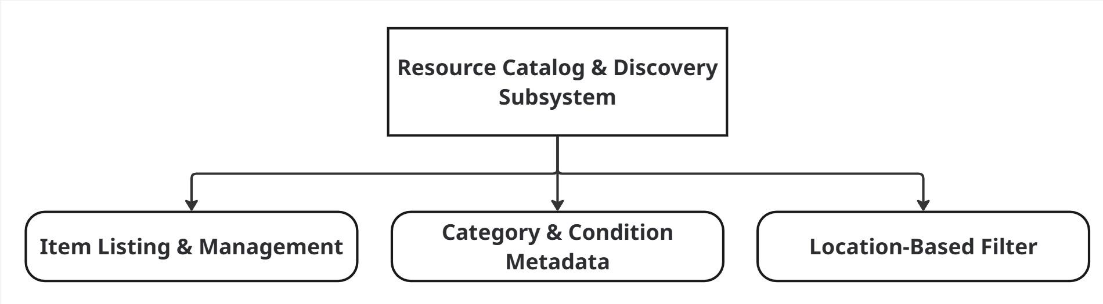
Figure 6.2.1:

Item Listing & Management
Lenders can easily upload a photo, title, and a brief description of the item they wish to share. This module handles the "Create, Read, Update, and Delete" (CRUD) functions for the item database.

Category & Condition Metadata
To keep the catalog organized, items are tagged by category (e.g., Lab Tools, Textbooks, Formal Wear). It also includes condition labels (New, Good, Fair) so borrowers know the state of the item before requesting it.

Location-Based Filter
Instead of complex GPS tracking, this module uses a simple selection system. Users can filter items by their residential college (e.g., KTF, KDI, KDO) or faculty to find resources within walking distance.

Transaction & Handover Subsystem
This subsystem manages the interaction between the borrower and the lender, ensuring a secure and verified physical exchange of items. It also includes basic safety tools for the community.
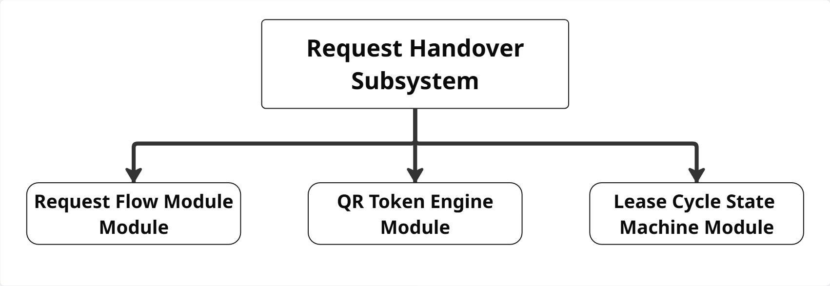
Figure 6.3.1:

Request & Approval Workflow
When a borrower finds an item, they send a digital request. The lender can then accept or reject the request. This module manages the communication and the agreement between both parties before the meeting.

QR Verification Module
To confirm that an item has been handed over safely, the system generates a unique QR code. The lender scans the borrower’s phone during the physical meeting, which automatically updates the status of the item to "Borrowed."

Community Moderation & Reporting
This module allows users to "Report" a listing if it is inappropriate. It also provides a basic interface for university staff to review these reports and remove items, ensuring the platform remains safe for all students.

PROPOSED TECHNOLOGY AND TOOLS USED

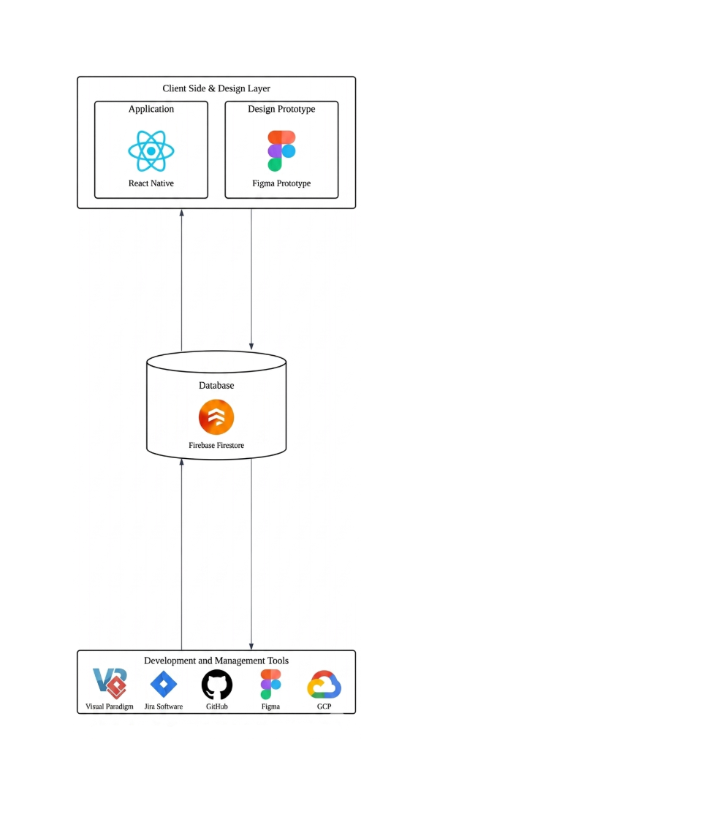
Modeling & Project Management Tools
To deliver a fully functional Application, the team will utilize a modern mobile development stack alongside collaborative design tools:

- Frontend Framework Flutter or React Native will be utilized to develop a cross-platform, high-performance mobile user interface for both Android and iOS devices.

- Backend & Database: Firebase (Authentication and Firestore) will serve as the cloud backend to manage secure user sessions, store item catalogs, and sync transaction logs in real-time.
- Figma: Used in the initial design phase (Weeks 7-9) to map user journeys and create high-fidelity UI/UX wireframes before moving into the actual coding phase.

Modeling & Project Management Tools:
- Visual Paradigm: The mandatory system architecture tool used to formulate exact UML schemas, including Use Case, Sequence, and Class diagrams for each subsystem.

- Generative AI (ChatGPT/Claude): Utilized to safely generate comprehensive system functional requirements, edge-case user personas, and state machine condition suggestions.

- Jira & GitHub: Jira acts as the project management board to track weekly task deliverables, while GitHub serves as the cloud repository for source code version control and documentation backup.

PROJECT BENEFITS
Starting the UTM Borrow System gives many advantages to students, the staff, and the university's goals for a clean campus.

Benefits for UTM Students (Financial & Space)
The biggest win is for the students. By switching from a "Buy" habit to a "Borrow" habit, students save a lot of money on tools they only need once. This helps students who don't have much money to get textbooks and tools without high costs. Also, dorm rooms are very small. This app helps students live with less "clutter" because they don't have to keep big items in their rooms that they only use once a year.

Benefits for UTM Administration and UTMCS
For the university staff, this app is a safe and organized way to share things compared to messy Telegram or WhatsApp groups. Because only "verified" people can join, the university has less spam in its official chats. It also stops outsiders from coming onto campus to trade things, because everyone must log in with their verified student email. This gives the university more control over student activities and ensures a safe, peer-to-peer environment.

Environmental Impact for the University
This system moves the campus closer to being a "Zero Waste" community. Every item borrowed instead of bought new helps the planet. By making things like laptop stands, calculators, and suits last longer on campus, the university lowers its waste. The Sustainability Impact Summary provides the university with reports to prove they are helping the world and meeting the UN Sustainable Development Goals (SDG 12)."

Future Entrepreneurial and Scaling Potential
    - Value-Added Services:
Instead of financial fees, the platform can introduce a "Gamified Boost" feature. Lenders with exceptionally high Trust Scores will earn tokenized community points, allowing them to highlight or "feature" their listings during high-demand periods (e.g., final exam weeks) to maximize resource circulation.
    - Market Scalability:
The "Circular Resource Sharing" model can be scaled beyond UTM to other Malaysian universities (UiTM, UM, etc.), creating a nationwide network for academic resource sharing.
    - Data-Driven Sustainability Reports:
The data collected by the platform regarding cost savings and waste reduction can be packaged as "Sustainability ROI Reports" for university management to support green funding initiatives.

PROJECT SCHEDULE

Phase | Weeks | Tasks | Deliverables | Responsible
Requirements | Week 1-3 | Literature review, questionnaire design, data collection (30+ responses), stakeholder analysis | Requirement Specification Document, Survey Analysis Report | All members (Individual subsystems)
Analysis | Week 4-6 | Use case diagrams, sequence diagrams, class diagrams for each subsystem | UML Diagrams (Visual Paradigm) | All members (Individual subsystems)
Design & Architecture | Week 7-9 | UI/UX wireframes in Figma, database schema design, and system architecture setup. | High-fidelity Figma design and Database Schema | All members (led by Resource Catalog & Discovery owner)
Prototyping | Week 10-12 | Frontend UI coding, Firebase integration, and API business logic implementation. | Fully functional mobile app codebase (GitHub repository) | All members (Individual subsystems)
Testing | Week 13-14 | Peer-to-peer testing, bug fixes, documentation finalization | Final Project Proposal, Testing Report | All members (Individual subsystems)

TEAM MEMBERS AND ROLES
To ensure specialized focus, each team member is assigned as the "Sub-system Owner" for one of the three core subsystems. They are responsible for the Requirements, design, prototype and testing of their specific Subsystem.

Subsystems and Responsible Team Members
Member Name | Responsible Subsystem | Core Technical Focus
AHMAT MAHAMAT | Identity & User Management | Authentication, Profile Trust Score, and User Dashboard logic.
MUAZ IBNE AHMED | Resource Catalog & Discovery | Item listing forms, Category metadata, and Location Filtering.
MOHAMMED ALSAKKAF | Transaction & Handover | Request/Approval workflow, QR verification, and Moderation reporting.

Waterfall Phase Responsibilities
- Requirement Phase:
- All members participate in data collection.
- Mohammed Mohsen & Muaz Ibne Ahmed draft the System Functional Requirements.
- Muaz Ibne Ahmed & Ahmat Mahamat finalize the non-functional requirements and community personas.
- Analysis & Design Phase:
- Each member creates the UML (Use Case, Sequence, and Class Diagrams) for their own specific module.
- Muaz Ibne Ahmed (Resource Catalog & Discovery) leads the Figma UI layout consistency to ensure the app looks professional.
- Mohammed Alsakkaf (Transaction & Handover) defines the logic for item request workflows and QR status changes.
- Implementation & Coding Phase:
- Each member develops their module's frontend and connects it to the shared backend.
- Ahmat (Identity & User Management) manages the shared User Database on Firebase to ensure secure data access for all modules.
- Testing:
- The team performs "Peer-to-Peer Testing," where members test a module they did NOT code to find bugs (e.g., Mohammed Mohsen tests Muaz Ibne Ahmed’s catalog filters).
- Mohammed Alsakkaf (Transaction & Handover) handles the final functional testing and validation of the reporting system.

INDIVIDUAL SCHEDULE

AHMAT MAHAMAT MOURDJI MOUSTAPHA — :Identity & User Management
Responsible for the authentication flow, user profile design, and the activity dashboard to track borrowed/lent items.

MUAZ IBNE AHMED — : Resource Catalog & Discovery
Responsible for the item listing interface, category management, and the college-based location filtering system.

MOHAMMED MOHSEN MOHAMMED ALSAKKAF — :Transaction & Handover
Responsible for the request/approval workflow, QR code generation/scanning logic, and community reporting features.

